South America Board Game

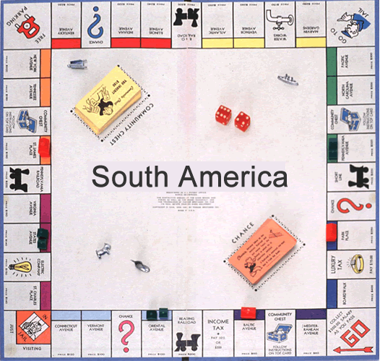

Objective:
You are a board game manufacturer, and you and your team have been assigned the task of creating a Monopoly-style board game set in South America. Make a game board, thoughtful and challenging question cards, and game pieces that demonstrate your understanding of the Five Themes of Geography and a cultural feature for 4-8 countries of your choice depending on the size of your group in a fun and interesting way!

GROUPINGS: The number of countries that are to be included in each project will depend on the size of each group as follows:

Independent: 4-5 countries
Pair: 4 countries (2 countries each)
Three: 6 countries (2 countries each)
Four: 8 countries (2 countries each)

ASSIGNMENT: You will create a board game that is based on the Five Themes of Geography and a cultural feature evidenced in 4-8 of the 13 South American countries we have studied (Brazil, French Guiana, Suriname, Guyana, Venezuela, Colombia, Ecuador, Peru, Bolivia, Chile, Argentina, Paraguay, and Uruguay). You will identify the South American countries that will be included in your board game and divide those countries between you. You will decide on the layout of your board game and the game pieces. You will then gather accurate information from your notes, handouts, and/or the textbook that supports each of the Five Themes of Geography and one cultural feature to help you create thoughtful and challenging question cards. You will also include game directions. Be creative and have FUN!

STEP-BY-STEP:
- Identify the South American countries you will include in your board game.

- Divide the work - Decide among yourselves who will be responsible for designing the game board, creating the game pieces (you will also need to include dice or a spinner to help players move around your game board), and game directions.

- Gathering Facts - Decide among yourselves who will be responsible for gathering facts for each of your chosen countries. For example, each of you might gather all facts for one country. Or, you might gather specific facts for all of your chosen countries (one of you might gather facts for Location and Place, one of you might gather facts for Human and Environmental Interaction and Movement, and another for Region and a cultural feature). You decide!

- Using your notes, graphic organizers, handouts, chapter PowerPoints, and/or the textbook, you will identify examples of each of the Five Themes of Geography and one cultural feature for each country that will be included in your board game to help you create thoughtful and challenging question cards.

  - Location – this requirement can be met by placing a political map of South America on your game board that includes the lines of latitude and longitude, as well as the oceans and seas. You can then mark the absolute location of each country on the map and through the game question cards, players can be asked to match the absolute location of a country with corresponding coordinates. The relative location of each country should also be included.

Game Card Absolute Location Map
Which country is located at
3° N, 53° W and is north of
Brazil?
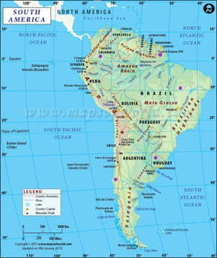
- Place – one example
- Human and Environmental Interaction – one example
- Movement – one example
- Region – one example
- Culture – one example that can include anything about languages, religions, festivals, clothing, music, dance, art, food, sports, etc. The possibilities are endless!

- Game Board: All game boards must be colored and neatly done on a large piece of white poster board or other strong material. When designing your game board, be sure to have a variety of spaces such as regular spaces, pick a card spaces, and move ahead/move back/lose a turn, etc. spaces. Also, your board must have a “start” and “finish” space. You will also need to make two card spaces in the middle of the board for question cards and discarded cards.

- Game Question Cards: Use a computer, index cards, or construction paper cut to approximately 2”x4’’ for each card that will have a question on one side and the answer on the other side. There is no limit to the number of cards, but six cards for each country is required.

- Game Pieces: Use buttons, coins, Legos, molding clay, or import yourself onto a South American image as a play piece using something like Pic Collage. You also need to include a spinner or dice to help players move around the game board. Be creative and make sure playing pieces reflect symbols of South America.

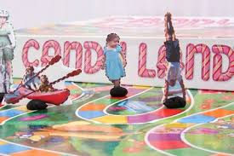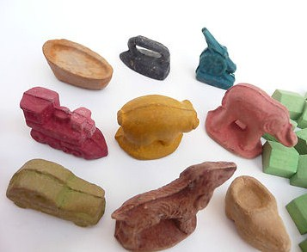

- Game Directions: Type directions for your game that would make it perfectly clear how to play the game. Game directions need to be on a sturdy piece of paper (laminated paper, cardboard, etc.)

- You will be provided with a time log to help ensure everyone is contributing equally, on task, and completing the necessary work.

- Be creative and have FUN!
GRADING: You will be graded according to the rubric that is provided with this project assignment. Please be sure to read the rubric carefully and constantly throughout the length of the project. You will also submit your time log.

DUE DATES:
Periods 2, 3, 6, and 7: Thursday, December 22nd

Period 5: Wednesday, December 21st

South American Country Information
(One “South American Country Information” form per country)

Country: ____________________________

Capital: ____________________________

Location Fact: _______________________________________________

_____________________________________________________________

Place Fact: _______________________________________________

_____________________________________________________________

Human and Environmental Interaction Fact: _______________________

_____________________________________________________________

_____________________________________________________________

Movement Fact: __________________________________________

_____________________________________________________________

_____________________________________________________________

Region Fact: _______________________________________________

_____________________________________________________________

_____________________________________________________________

Cultural Fact: _______________________________________________

_____________________________________________________________

Additional Facts: _______________________________________________

_____________________________________________________________

_____________________________________________________________

_____________________________________________________________

_____________________________________________________________

_____________________________________________________________

_____________________________________________________________

_____________________________________________________________

_____________________________________________________________

_____________________________________________________________

_____________________________________________________________

_____________________________________________________________

_____________________________________________________________

_____________________________________________________________

_____________________________________________________________

_____________________________________________________________

_____________________________________________________________

_____________________________________________________________

_____________________________________________________________

_____________________________________________________________

_____________________________________________________________

_____________________________________________________________

