South America Travel Brochure

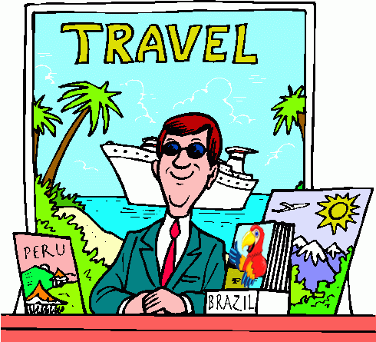

Objective:
You are a travel agent at Cohasset Travel who has been asked to develop a travel brochure of South America. Use a template in Microsoft Word or Apple Pages or free online tools such as https://www.mystorybook.com to make a brochure that provides information related to the Five Themes of Geography and a cultural feature for 4-8 countries of your choice depending on the size of your group.

GROUPINGS: The number of countries that are to be included in each project will depend on the size of each group as follows:

Independent: 4-5 countries
Pair: 4 countries (2 countries each)
Three: 6 countries (2 countries each)
Four: 8 countries (2 countries each)

ASSIGNMENT: You will create a travel brochure that is based on the Five Themes of Geography and a cultural feature evidenced in 4-8 of the 13 South American countries we have studied (Brazil, French Guiana, Suriname, Guyana, Venezuela, Colombia, Ecuador, Peru, Bolivia, Chile, Argentina, Paraguay, and Uruguay). You will identify the South American countries that will be included in your travel brochure and divide those countries between you. You will decide on the media (Microsoft Word or Apple Pages or free online tools such as https://www.mystorybook.com) that you will use to create your travel brochure. You will then gather accurate information from your notes, handouts, and/or the textbook that supports each of the Five Themes of Geography and one cultural feature. You will then create your travel brochure. Be creative and have FUN!

STEP-BY-STEP:
- Identify the South American countries you will include in your travel brochure.

- Choose the media (Microsoft Word or Apple Pages or free online tools such as https://www.mystorybook.com) that you will use to create your travel brochure. If there is another media that you are more familiar with, you are encouraged to use that media with my approval.

- Divide the work - Decide among yourselves who will be responsible for gathering facts for which countries. For example, each of you might gather all facts for one country. Or, each of you might gather specific facts for all of your chosen countries (one might gather facts for Location and Place, one might gather facts for Human and Environmental Interaction and Movement, and another for Region and a cultural feature). You decide!

- Using your notes, graphic organizers, handouts, chapter PowerPoints, and/or the textbook, you will identify examples of each of the Five Themes of Geography and one cultural feature for each country you spotlight in your travel brochure.

  - Location – this requirement can be met by placing a political map of South America in your travel brochure that includes the lines of latitude and longitude, as well as the oceans and seas. You can then provide the absolute location of each country within a frame. The relative location of each country should also be included.
French Guiana
is located
at 3° N, 53° W
and is north
of Brazil.
- Place – one example
- Human and Environmental Interaction – one example
- Movement – one example
- Region – one example
- Culture – one example that can include anything about languages, religions, festivals, clothing, music, dance, art, food, sports, etc. The possibilities are endless!

- You will be provided with a fact gathering worksheet to help you organize your facts.

- After you have gathered the required facts, agree upon the layout of your travel brochure. Identify who will be responsible for creating which parts of the travel brochure. You will be provided with a time log to help ensure everyone is contributing equally, on task, and completing the necessary work.

- Be creative and make sure your travel brochure is easily readable.

GRADING: You will be graded according to the rubric that is provided with this project assignment. Please be sure to read the rubric carefully and constantly throughout the length of the project. You will also submit your time log.

DUE DATES:
Periods 2, 3, 6, and 7: Thursday, December 22nd

Period 5: Wednesday, December 21st

South American Country Information
(One “South American Country Information” form per country)

Country: ____________________________

Capital: ____________________________

Location Fact: ________________________________________

____________________________________________________

Place Fact: __________________________________________

____________________________________________________

Human and Environmental Interaction Fact: ________________

____________________________________________________

Movement Fact: _______________________________________

____________________________________________________

Region Fact: __________________________________________

____________________________________________________

Cultural Fact: _________________________________________

____________________________________________________

Additional Facts: ______________________________________

____________________________________________________

____________________________________________________

____________________________________________________

____________________________________________________

____________________________________________________

____________________________________________________

____________________________________________________

____________________________________________________

____________________________________________________

____________________________________________________

____________________________________________________

____________________________________________________

____________________________________________________

____________________________________________________

____________________________________________________

____________________________________________________

____________________________________________________

____________________________________________________

